Design Support documents



**Frame**

***Objectives***

The objective of this document is to illustrate the different tools and approaches we used in order to design the frame of OPTIMUS. Our goal was to enhance the **position of the pilot**, as well as the **dynamic behavior**. All of this while **reducing the weight** and reduce over-dimensioning, persisting in this department.

***Conception steps***

To begin with, we set objectives, summated constraints imposed by the rules and located improvements opportunities, in order to structure and define our work. Then, a preconception phase instituted the basics of the development that was brought in detailed conception. This consisted of an **iterative process** between CAD and simulations and **interface management** with other systems.

***Assumptions***

We realised simulations under the following assumptions.

* Elastic behaviour
* Small displacement
* No dynamic phenomenon
* Welding beams as resistant as tubes

The assumptions above are mecanically coherent with our situation and with the real-life mecanical tests realized.

***Important values***

|  |  |  |  |
| --- | --- | --- | --- |
|  | Target | Simulation | Measure |
| Stiffness (Nm/deg) | 1100-1300 | 1114 | 1169 |
| Weight (with paint and equipment) (kg) | 39-42 | 40.6 | 41 |

* Steel: 25CrMo4 (AISI4130)
* Yield strength: 789 MPa

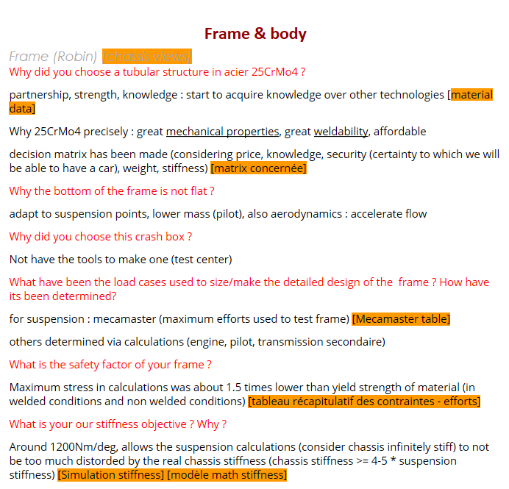

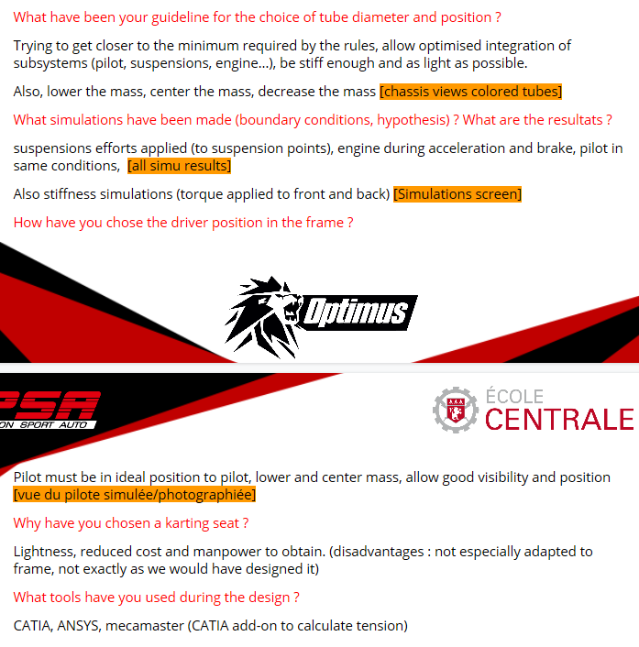

Loads table

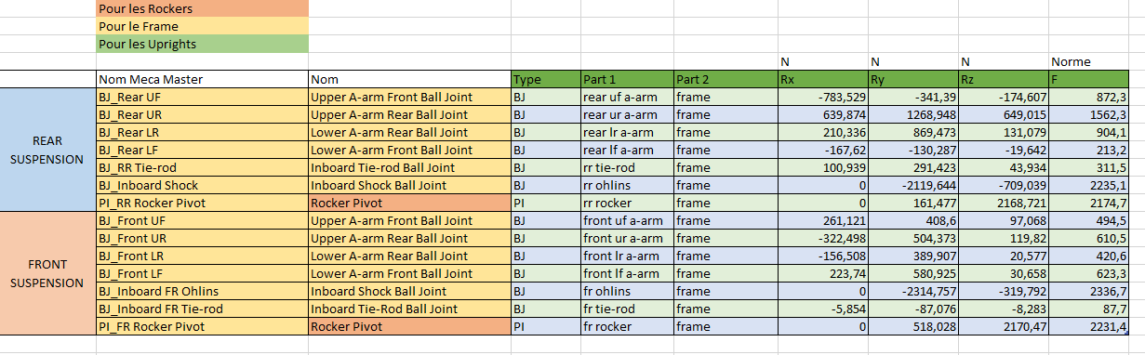

Example of load table for Bumping 3G

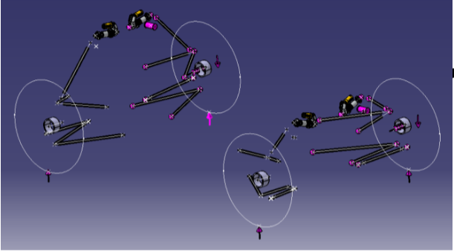

Mecamaster model of OPTIMUS

Simulation tests results

NB: Except for torsion, all load cases come from MécaMaster

Figure 1: Torsion

Figure 2a: Acceleration 0.77g

Figure 2b: Acceleration 0.77g

Figure 3a: Braking 2g

Figure 3b: Braking 2g

Figure 4a: Bump 3g

Figure 4b: Bump 3g

Figure 5a: Left turn 2g

Figure 5b: Left turn 2g

Figure 6a: Left turn 1g + braking 1g

Figure 6b: Left turn 1g + braking 1g

The following table summarizes the main results of the different simulations

|  |  |  |  |
| --- | --- | --- | --- |
| Simulation type | Maximum stress | Location | Maximum displacement |
| Torsion |  |  |  |
| Acceleration 0.77g |  |  |  |
| Braking 2g |  |  |  |
| Bump 3g |  |  |  |
| Left turn 2g |  |  |  |
| Left turn 1g + braking 1g |  |  |  |

Stiffness measure experiment

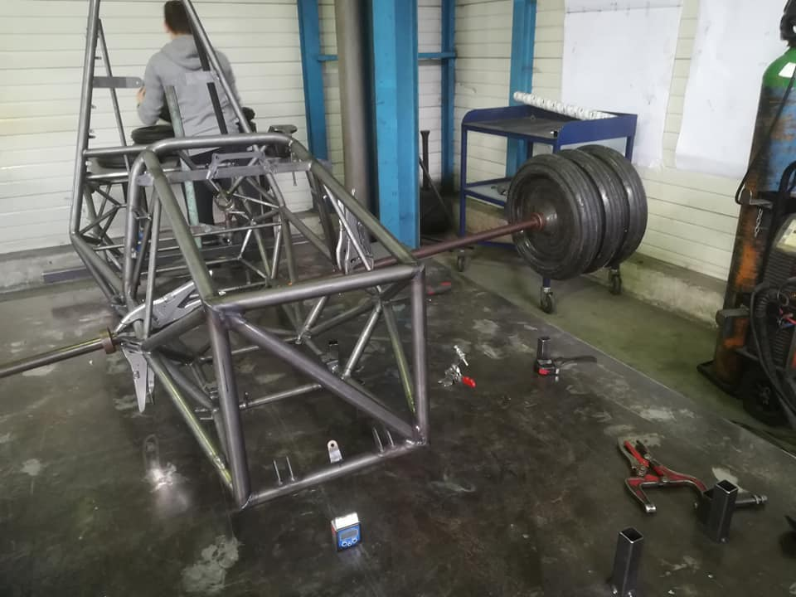 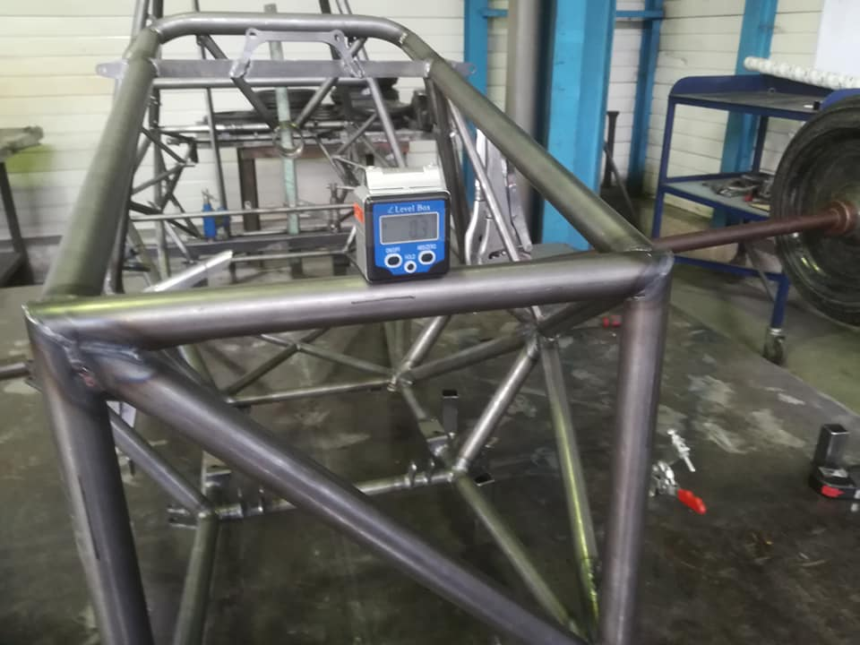

Figure 7: Stiffness measurement on the frame

Measure performed in two times (distance to longitudinal axis approx. 1m):

* Apply a torque to the front and the cockpit of the frame, blocking the back
* Apply a torque at the back, blocking the front

Stiffness measurements results:

*Weights used: 65kg*

*Angles of torsion measured: 0.7 degrees*

*Results: 1191Nm/deg*

*1147Nm/deg*

Hence our **torsional stiffness** of **1169Nm/deg**

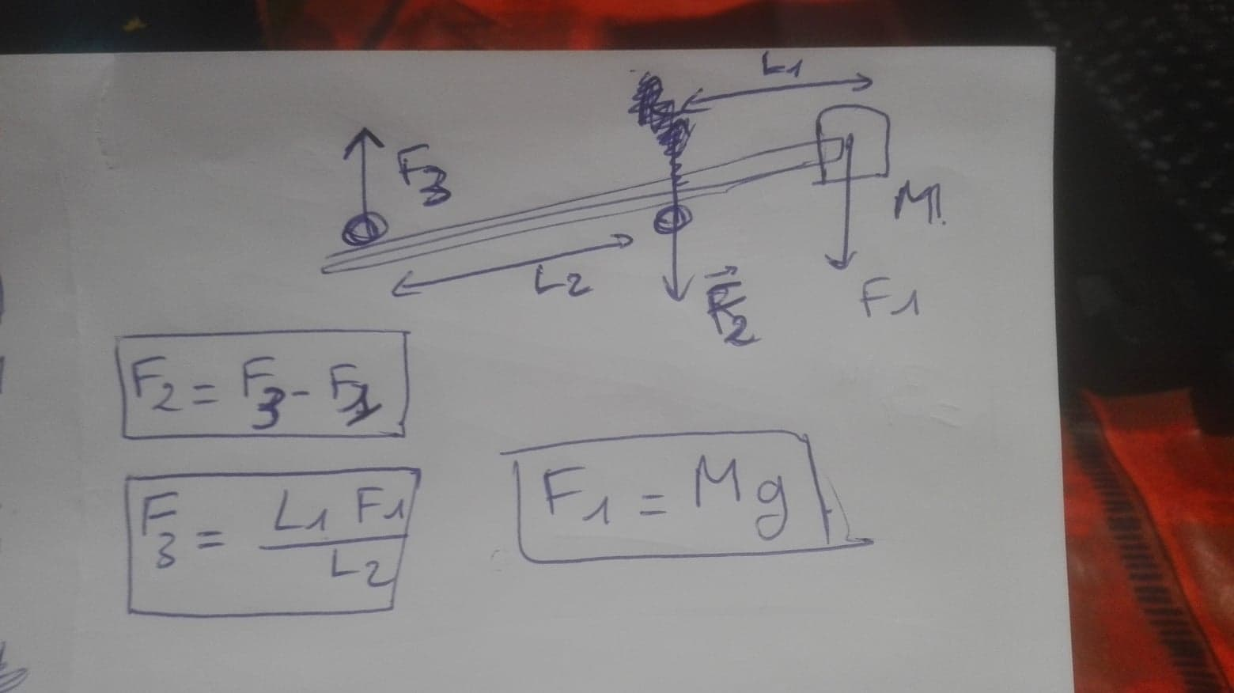

Stiffness calculations explanation

Equipment positioning

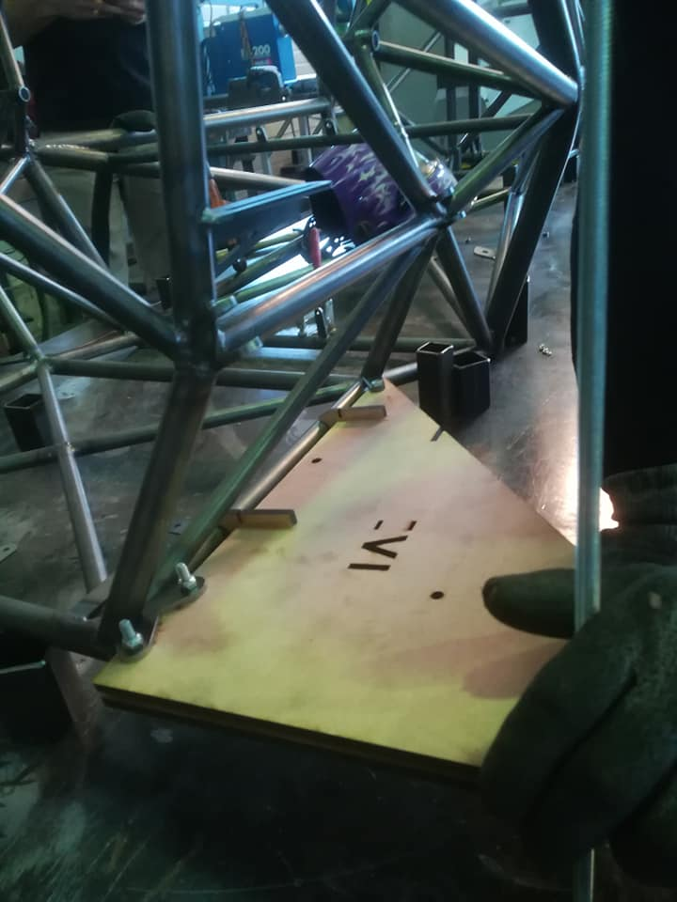

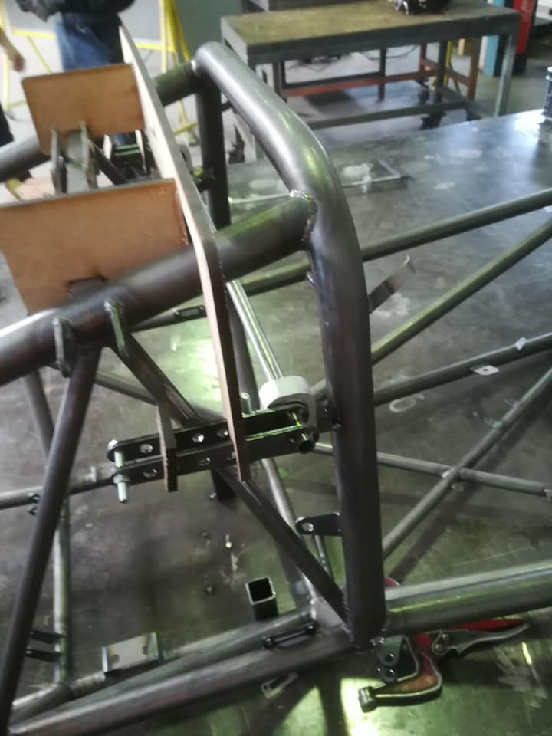 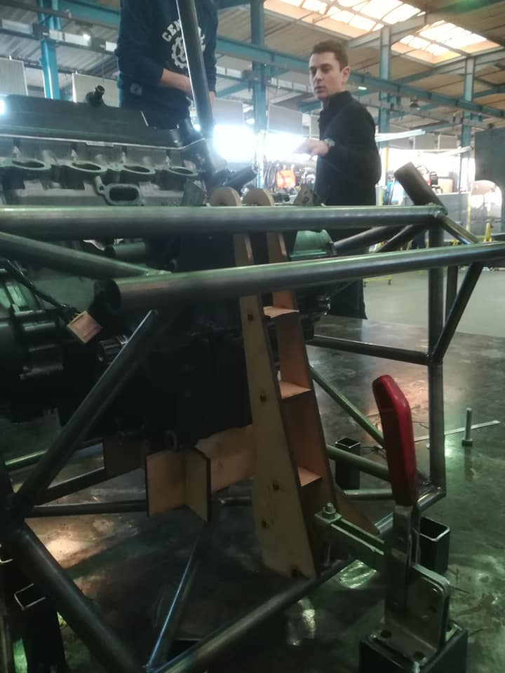 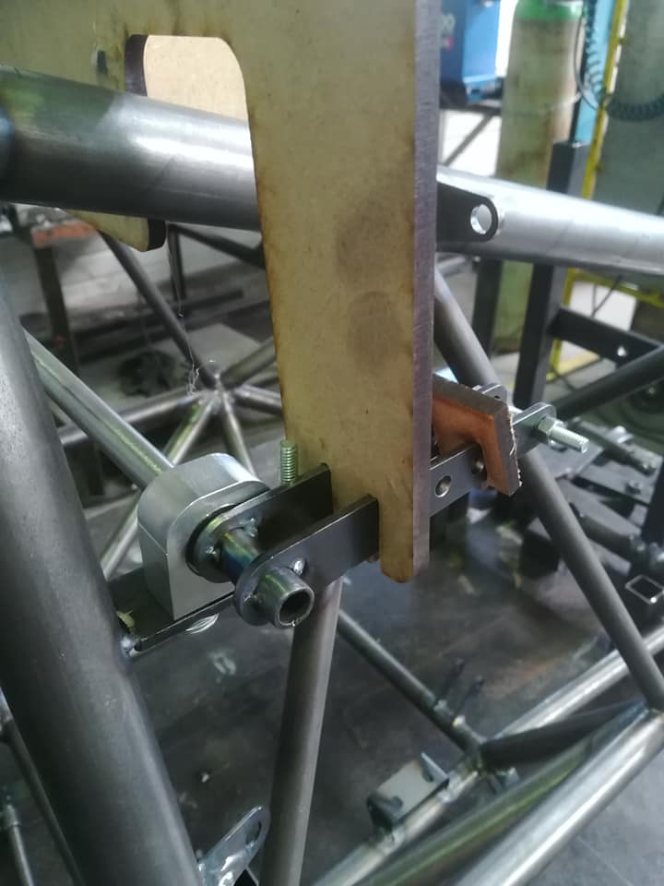

*Figure 8: Use of templates to precisely position equipments during welding*

Pilot position

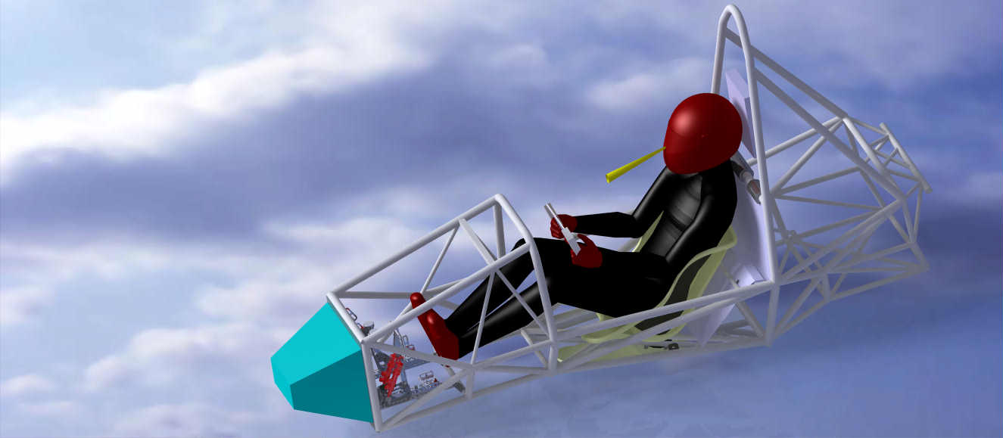

Figure 10: Human model in CAD model to help designing the chassis

Tensile strength test results

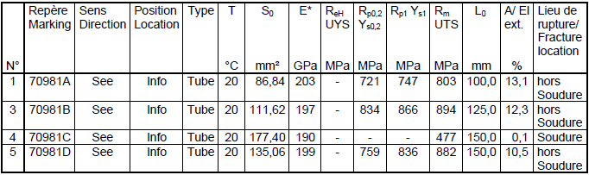

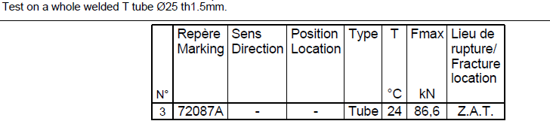



Mechanical data in welded and non-welded condition

Appendix

Stiffness model (coefficient 𝛼)

Frame: three series torsion springs

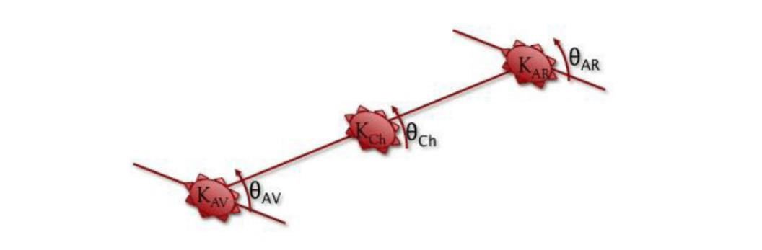

Figure 9: Definition of the model

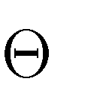Where *K*=stiffness and *θ* =angle. We also define 𝐾𝑇 and 𝜃𝑇 respectively the stiffness and the angle of the car.

In order to simplify the equations, we suppose 𝐾𝐴𝑉 = 𝐾𝐴𝑅; 𝛼. 𝐾𝐴𝑉 = 𝐾Ch 𝑎𝑛𝑑 𝜃𝐴𝑉 = 𝜃𝐴𝑅. It gives us the following equations:

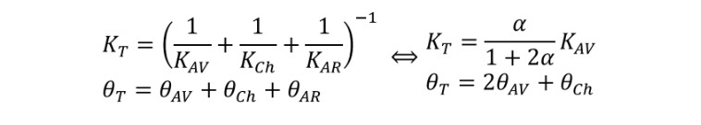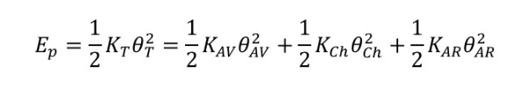

Finally, A COMPRENDRE cf epsabox

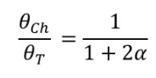

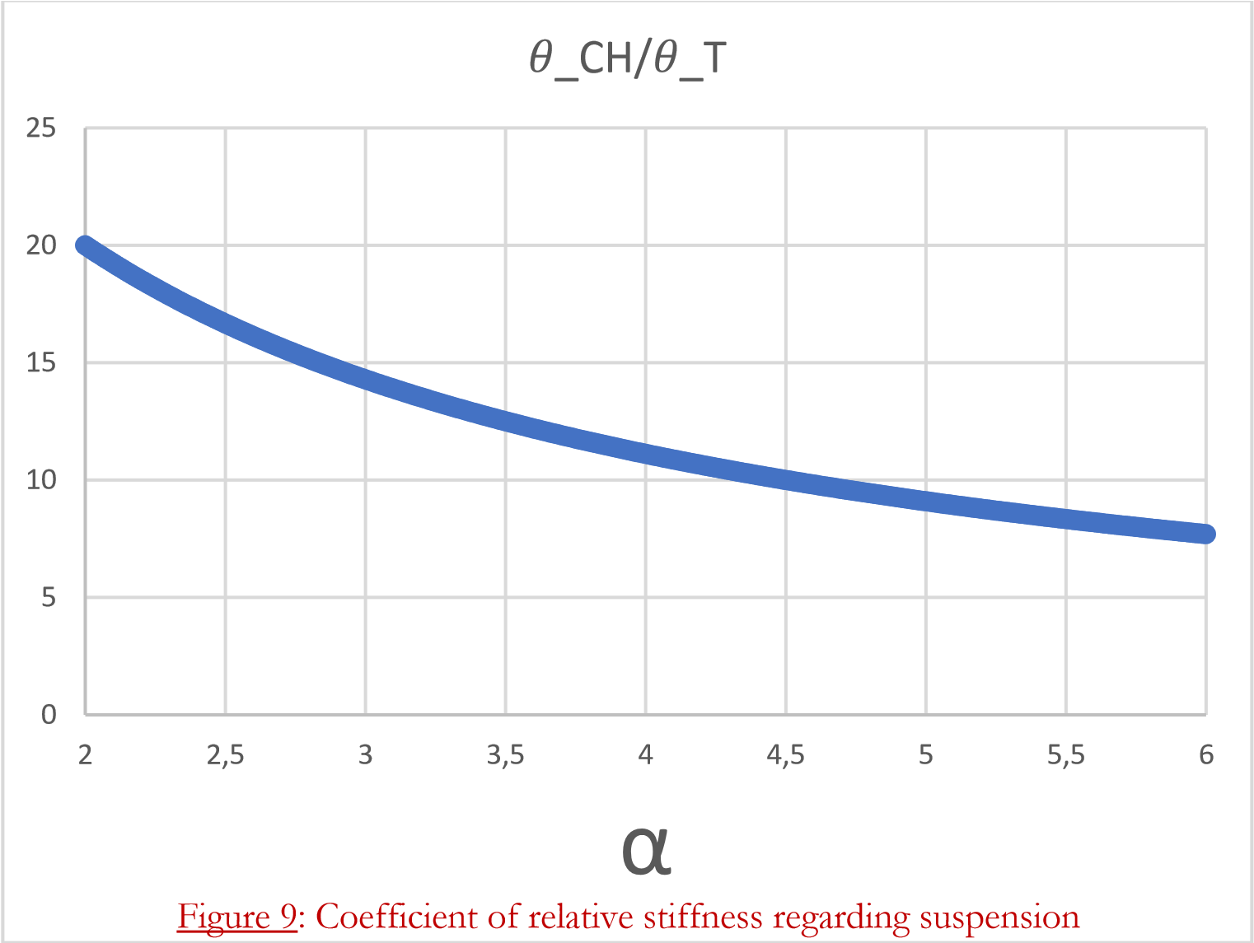

Coefficient of relative stiffness regarding suspension

If we want to keep 𝜃𝐶𝐻/𝜃𝑇 between 10% and 15%, we have to take α between 3 and 5.